3.42: a) The speed relative to the water is still 4.2 m/s; the necessary heading of the boat is 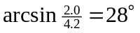 north of east. b) 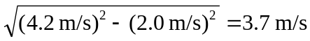, east. d) 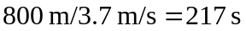, rounded to three significant figures.

